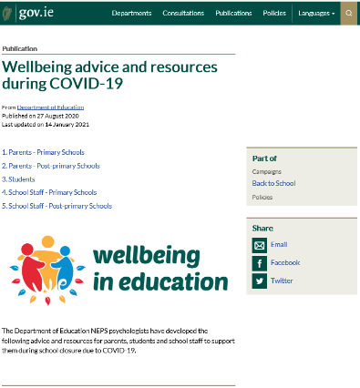

The Department of Education National Educational Psychology Service (NEPS) have many resources that you may find useful while the school is closed. These resources can be found on the Department website here

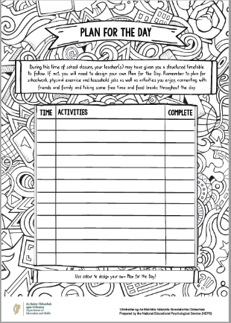
Plan for a Day
A plan for the day template is available here to help you and your child put a structure on the day. It suggests trying to have a schedule, creating time for fun activities, time for learning, break times and time for physical activity.

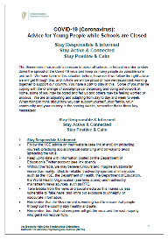
Advice for Young People
NEPS has published Advice for Young People while Schools are Closed which is available here

Relaxation Techniques Podcast
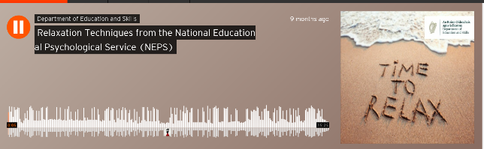
This link will take you to a podcast from NEPS to help parents and pupils practise relaxation techniques.

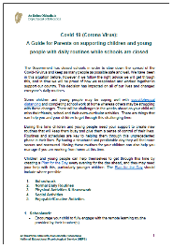
Advice for Parents
NEPS has also published A Guide for Parents on Supporting Children and Young People with Daily Routines while Schools are Closed which is available here

